day2:

-------

Assignment 1: SDLC Overview - Create a one-page infographic that outlines the SDLC phases (Requirements, Design, Implementation, Testing, Deployment), highlighting the importance of each phase and how they interconnected.

**Software Development Life Cycle (SDLC):**

Software Development Life Cycle (SDLC) is a process used by the software industry to design, develop and test high quality software. The SDLC aims to produce a high-quality software that meets or exceeds customer expectations, reaches completion within times and cost estimates.

* Phase 1: Planning
* Phase 2: Requirements Analysis
* Phase 3: Design
* Phase 4: Coding
* Phase 5: Testing
* Phase 6: deployment
* Phase 7: Maintenance

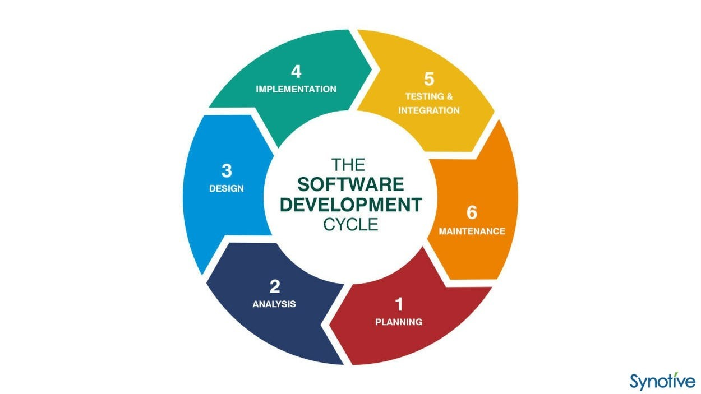

Phase 1: Planning:

The planning stage (also called the feasibility stage) is exactly what it sounds like the phase in which developers will plan for the upcoming project.

It helps to define the problem and scope of any existing systems, as well as determine the objectives for their new systems.

Phase 2: Requirements Analysis

Gathering and understanding user requirements is crucial for building a system that meets users’ needs. This phase ensures that the development team has a clear understanding of what the software should achieve.

Phase 3: Design

The design phase focuses on converting the requirements into a blueprint for the software system. It includes both high-level design (architecture) and low-level design (detailed specifications for each component).

Phase 4: Coding

This is the phase where the actual code for the software is written based on the design specifications. It transforms the design into a working system

Developers write, test, and debug the code. This phase involves adhering to coding standards, best practices, and ensuring that the code meets the requirements outlined in the earlier phases.

Phase 5: Testing

The testing phase is crucial for identifying and fixing defects or issues in the software. It ensures that the software meets quality standards before deployment.

Testing is performed at various levels, including unit testing (individual components), integration testing (combining components), system testing (testing the entire system), and user acceptance testing (ensuring the software meets user expectations).

Phase 6: Deployment

Deployment involves making the software available for end-users. It includes installation, configuration, and sometimes data migration.

The software is released to the production environment. Deployment may involve collaboration between developers and system administrators to ensure a smooth transition from development to production.

Phase 7: Maintenance

After deployment, the software requires ongoing maintenance to address issues, apply updates, and make improvements. This phase ensures the long-term reliability and effectiveness of the software.

The development team provides ongoing support, monitors the software for issues, and implements necessary changes. Maintenance may include bug fixes, security updates, and the introduction of new features.

Assignment 2: Develop a case study analyzing the implementation of SDLC phases in a real-world engineering project. Evaluate how Requirement Gathering, Design, Implementation, Testing, Deployment, and Maintenance contribute to project outcomes.

Case study: Development of a Smart Home Automation System

#### Objective:

To develop a smart home automation system that allows homeowners to control lighting, temperature, security, and appliances remotely using a smartphone app.

### SDLC Phases Analysis

#### 1. Requirements Gathering and Analysis

**Objective:** To understand the needs and expectations of homeowners for a smart home automation system.

**Activities:**

* Conducted interviews and surveys with potential users to identify key features (e.g., remote control of lights, thermostats, security cameras).
* Analyzed existing home automation systems to identify strengths and weaknesses.
* Created a detailed Requirements Specification document.

**Result:** A comprehensive list of features and functionalities that the system should include, ensuring alignment with user needs and market demand.

#### 2. System Design

**Objective:** To create a blueprint for the smart home automation system, specifying hardware and software requirements.

**Activities:**

* Designed the system architecture, including the integration of sensors, controllers, and the mobile app.
* Developed user interface mockups for the smartphone app.
* Prepared detailed design documents outlining the technical specifications and workflows.

**Result:** Clear and detailed design documentation that guides the development team, reducing ambiguity and potential design-related issues.

#### 3. Coding

**Objective:** To develop the smart home automation system according to the design specifications.

**Activities:**

* Developers wrote the code for the mobile app, sensor integrations, and backend server.
* Implemented security features to protect user data and ensure system integrity.
* Conducted code reviews to ensure quality and consistency.

**Result:** A fully functional prototype of the smart home automation system, ready for testing.

#### 4. Testing

**Objective:** To ensure the system functions correctly and meets all specified requirements.

**Activities:**

* Performed unit testing on individual components (e.g., sensors, app features).
* Conducted integration testing to ensure all components work together seamlessly.
* Ran user acceptance testing (UAT) with a group of homeowners to gather feedback and identify any issues.

**Result:** A reliable and user-friendly smart home automation system with identified bugs fixed, ensuring it meets user expectations and requirements.

#### 5. Deployment

**Objective:** To release the smart home automation system to the market.

**Activities:**

* Planned and executed the deployment, including setting up the production environment.
* Provided training and documentation for users to help them get started with the system.
* Launched marketing campaigns to promote the new product.

**Result:** Successful deployment of the smart home automation system, with positive initial user feedback and increasing market adoption.

#### 6. Maintenance

**Objective:** To ensure the smart home automation system remains functional and up-to-date.

**Activities:**

* Monitored system performance and responded to user reports of any issues.
* Released regular updates to add new features and improve existing ones based on user feedback.
* Conducted routine maintenance to ensure system security and performance.

**Result:** Continued user satisfaction and system reliability, with an expanding user base and ongoing improvements that keep the product competitive in the market.

Assignment 3: Research and compare SDLC models suitable for engineering projects. Present findings on Waterfall, Agile, Spiral, and V-Model approaches, emphasizing their advantages, disadvantages, and applicability in different engineering contexts.

### Comparison of SDLC Models for Engineering Projects

When selecting an SDLC model for engineering projects, it's crucial to understand the strengths and weaknesses of each approach. Below is a comparison of four commonly used SDLC models: Waterfall, Agile, Spiral, and V-Model.

#### 1. Waterfall Model

**Overview:** The Waterfall model is a linear and sequential approach where each phase must be completed before the next one begins. It is one of the oldest and most traditional SDLC models.

#### 2. Agile Model

**Overview:** The Agile model emphasizes iterative development, where requirements and solutions evolve through collaboration between self-organizing cross-functional teams.

#### 3. Spiral Model

**Overview:** The Spiral model combines iterative development with systematic aspects of the Waterfall model. It focuses on risk assessment and reduction through repeated cycles (or spirals).

#### 4. V-Model (Verification and Validation Model)

**Overview:** The V-Model is an extension of the Waterfall model that emphasizes verification and validation at each stage of development. It is also known as the Validation and Verification model

|  |  |  |  |
| --- | --- | --- | --- |
| **Model** | **Advantages** | **Disadvantages** | **Applicability** |

|  |  |  |  |
| --- | --- | --- | --- |
| Waterfall | Simple, well-defined stages, good documentation | Inflexible, late testing, poor adaptability | Well-defined, stable requirements projects |

|  |  |  |  |
| --- | --- | --- | --- |
| Agile | Flexible, customer collaboration, early delivery | Less predictable, requires experience, less documentation | Dynamic, rapidly changing requirements |

|  |  |  |  |
| --- | --- | --- | --- |
| Spiral | Risk management, iterative development, flexible | Complex, costly, time-consuming | Large, complex, high-risk projects |

|  |  |  |  |
| --- | --- | --- | --- |
| V-Model | Early defect detection, structured, high quality | Inflexible, resource-intensive, sequential | High reliability, safety-critical systems |